**Web Programming Lab 3: Introduction to Arrays**

1. The output of the code for question 1 (Question_1.php)

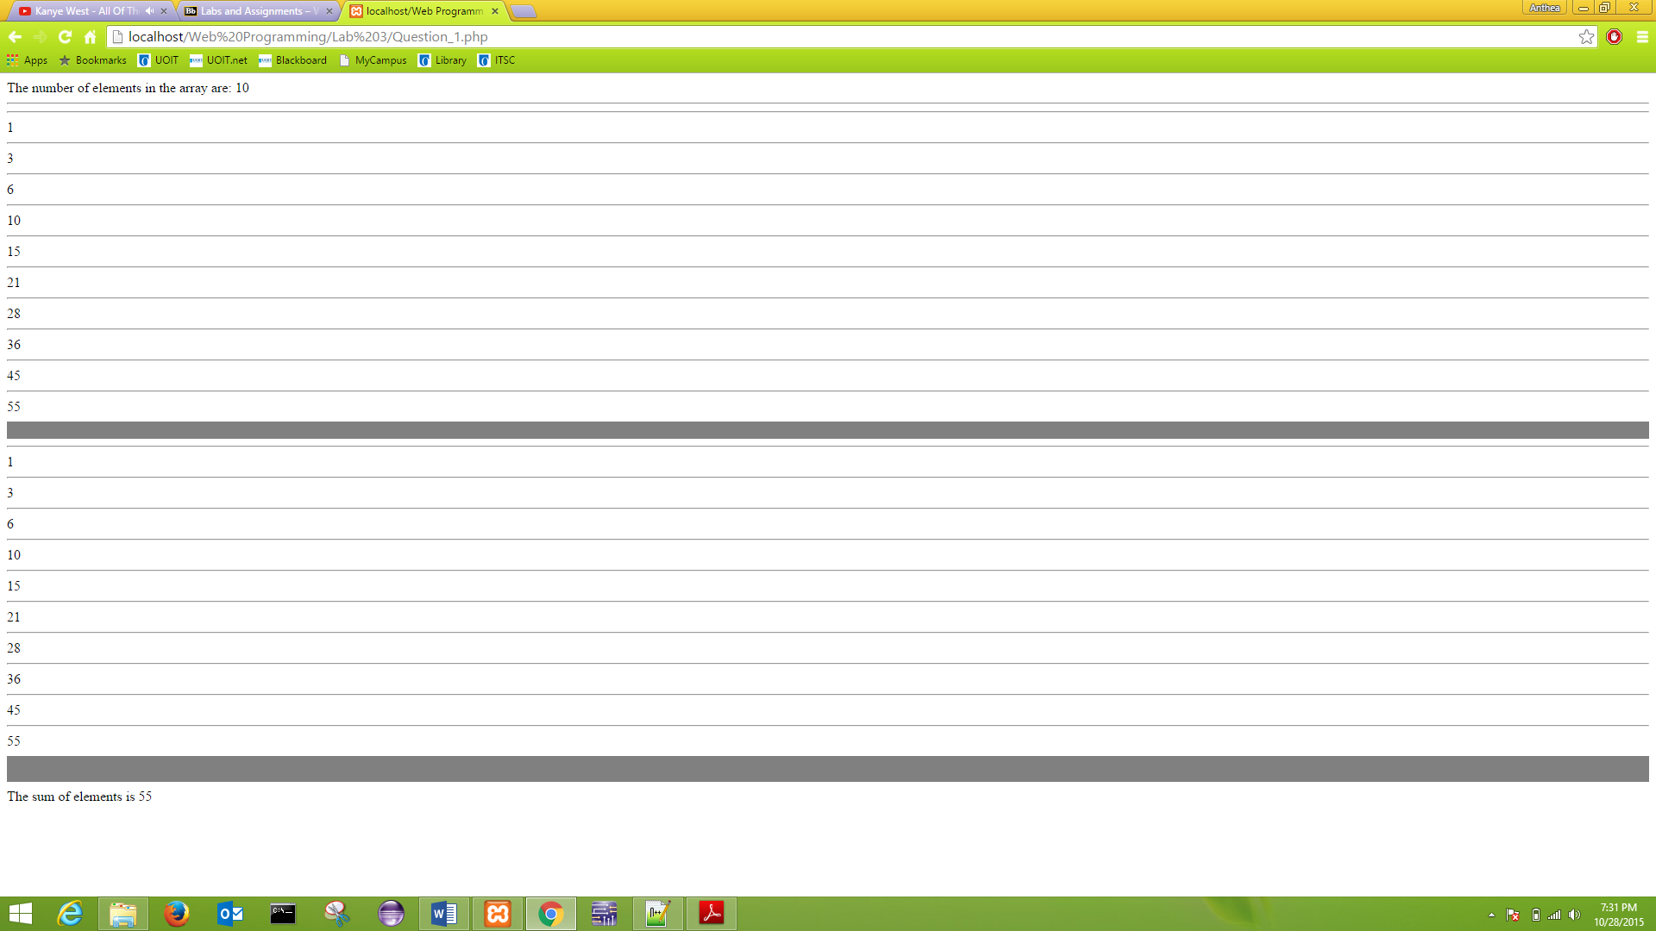

1. The output for 2-2.5. (Question_2.php)

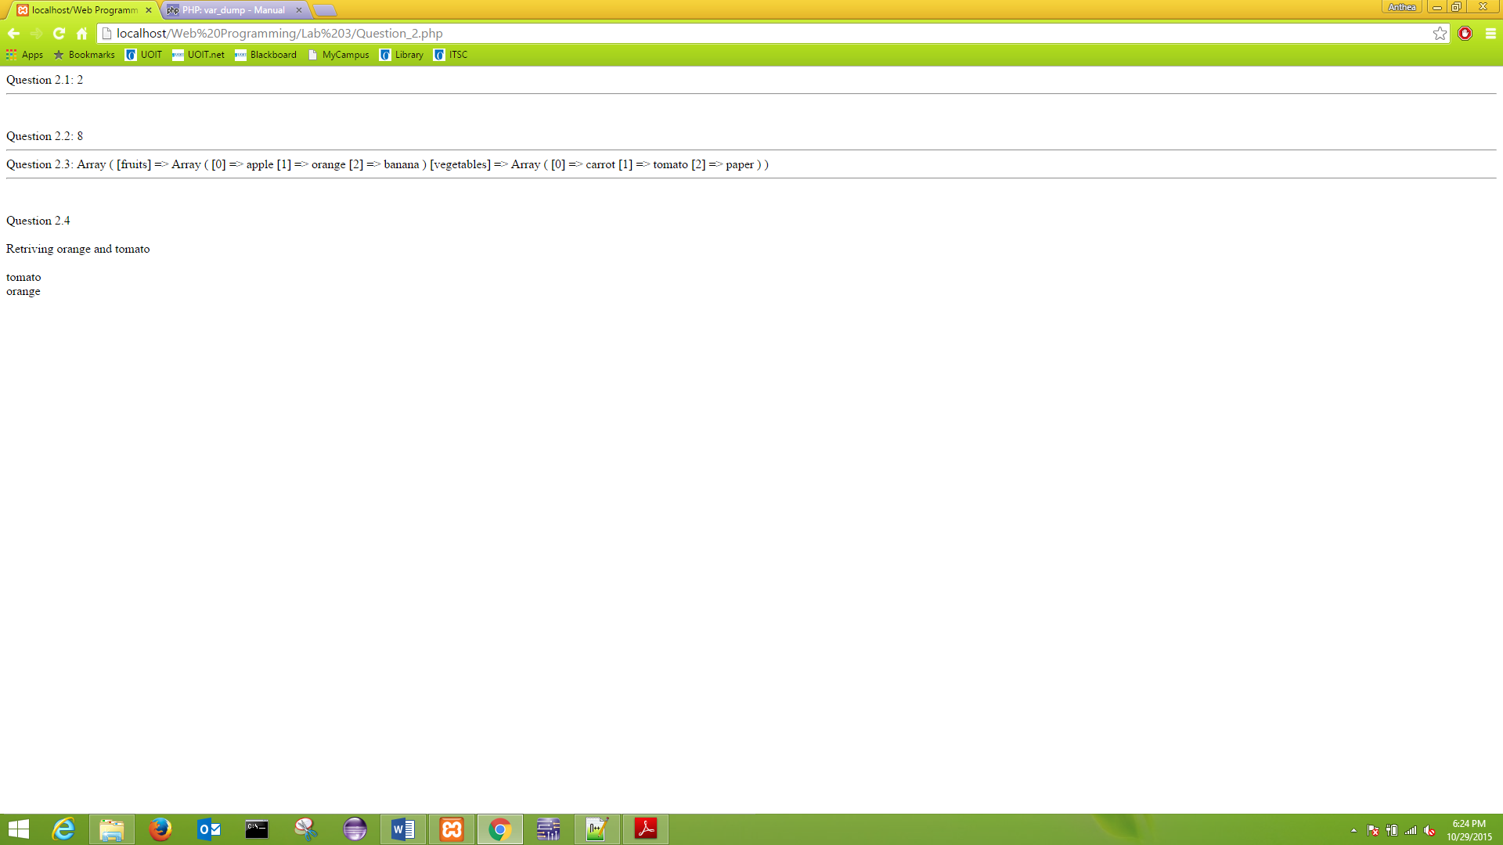

1. The output of the code. (Question_3.php)

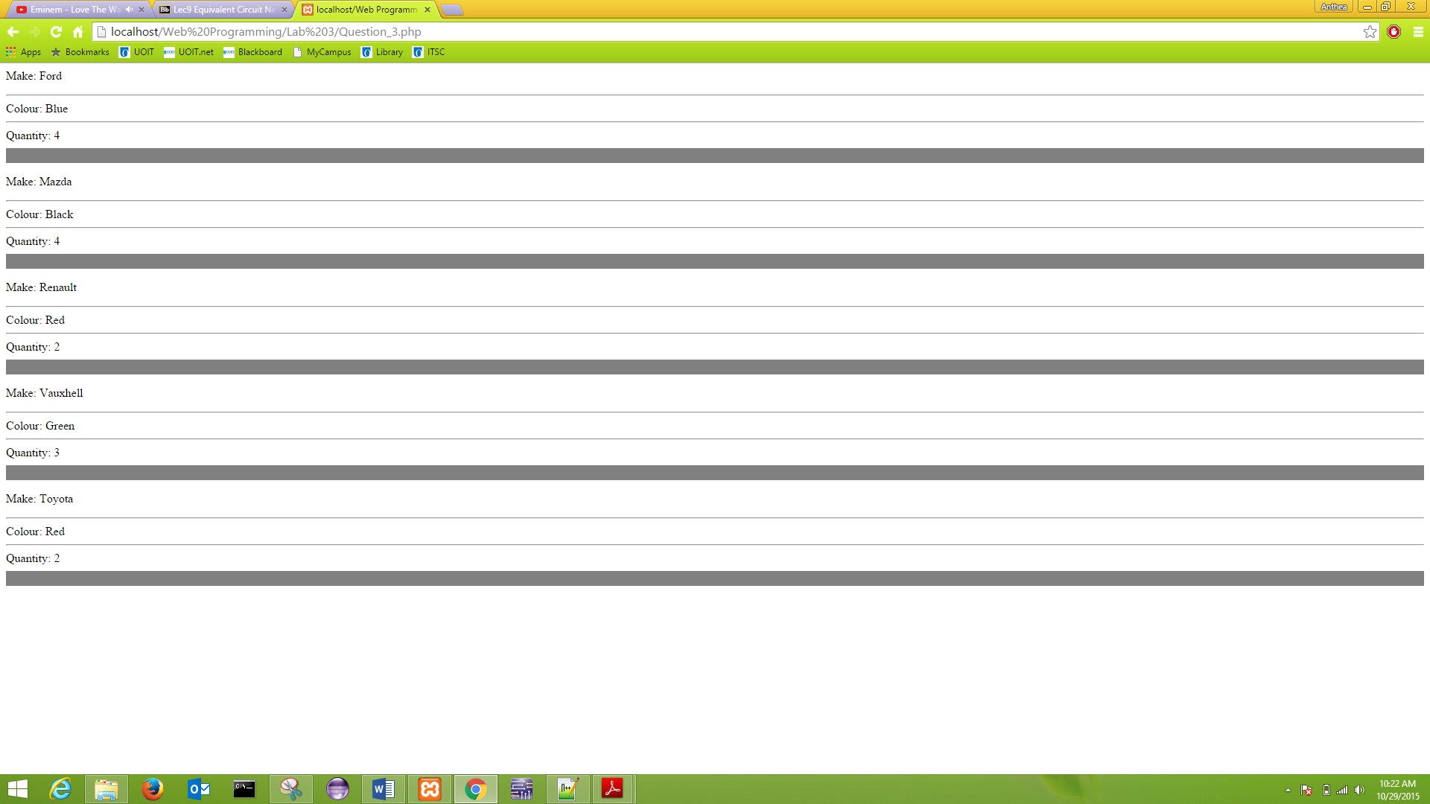

1. 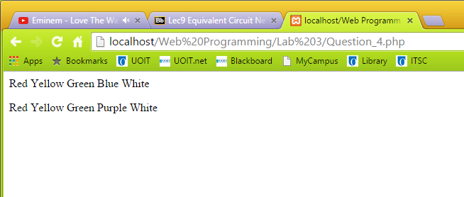The output of the code before and after replacing blue for purple in the array. (Question_4.php)
2. The output of the code. (Question_5.php)

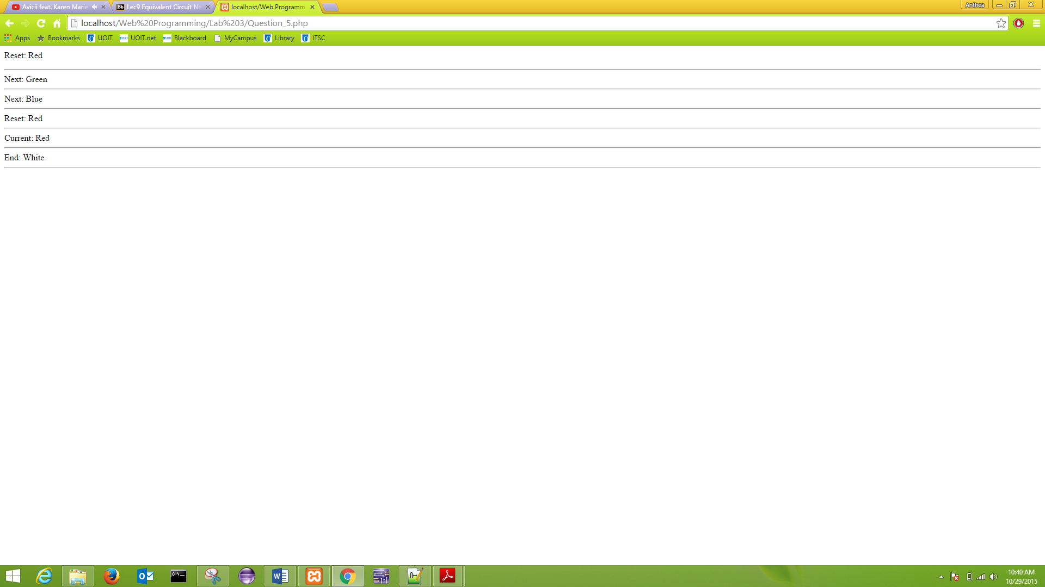

5.1) The role of the reset() function is to retrieve the value of the first key in an array. In this case the key 0 has the value “Red”. Therefore the reset() function will retrieve the value “Red” and store it in the variable $strColour.

5.2) The role of the end() function is to retrieve the value of the last in an array. In this case the last key, 4, has the value “White”. Therefore the end() function will retrieve the value “White” and store it in the variable $strColour.

1. 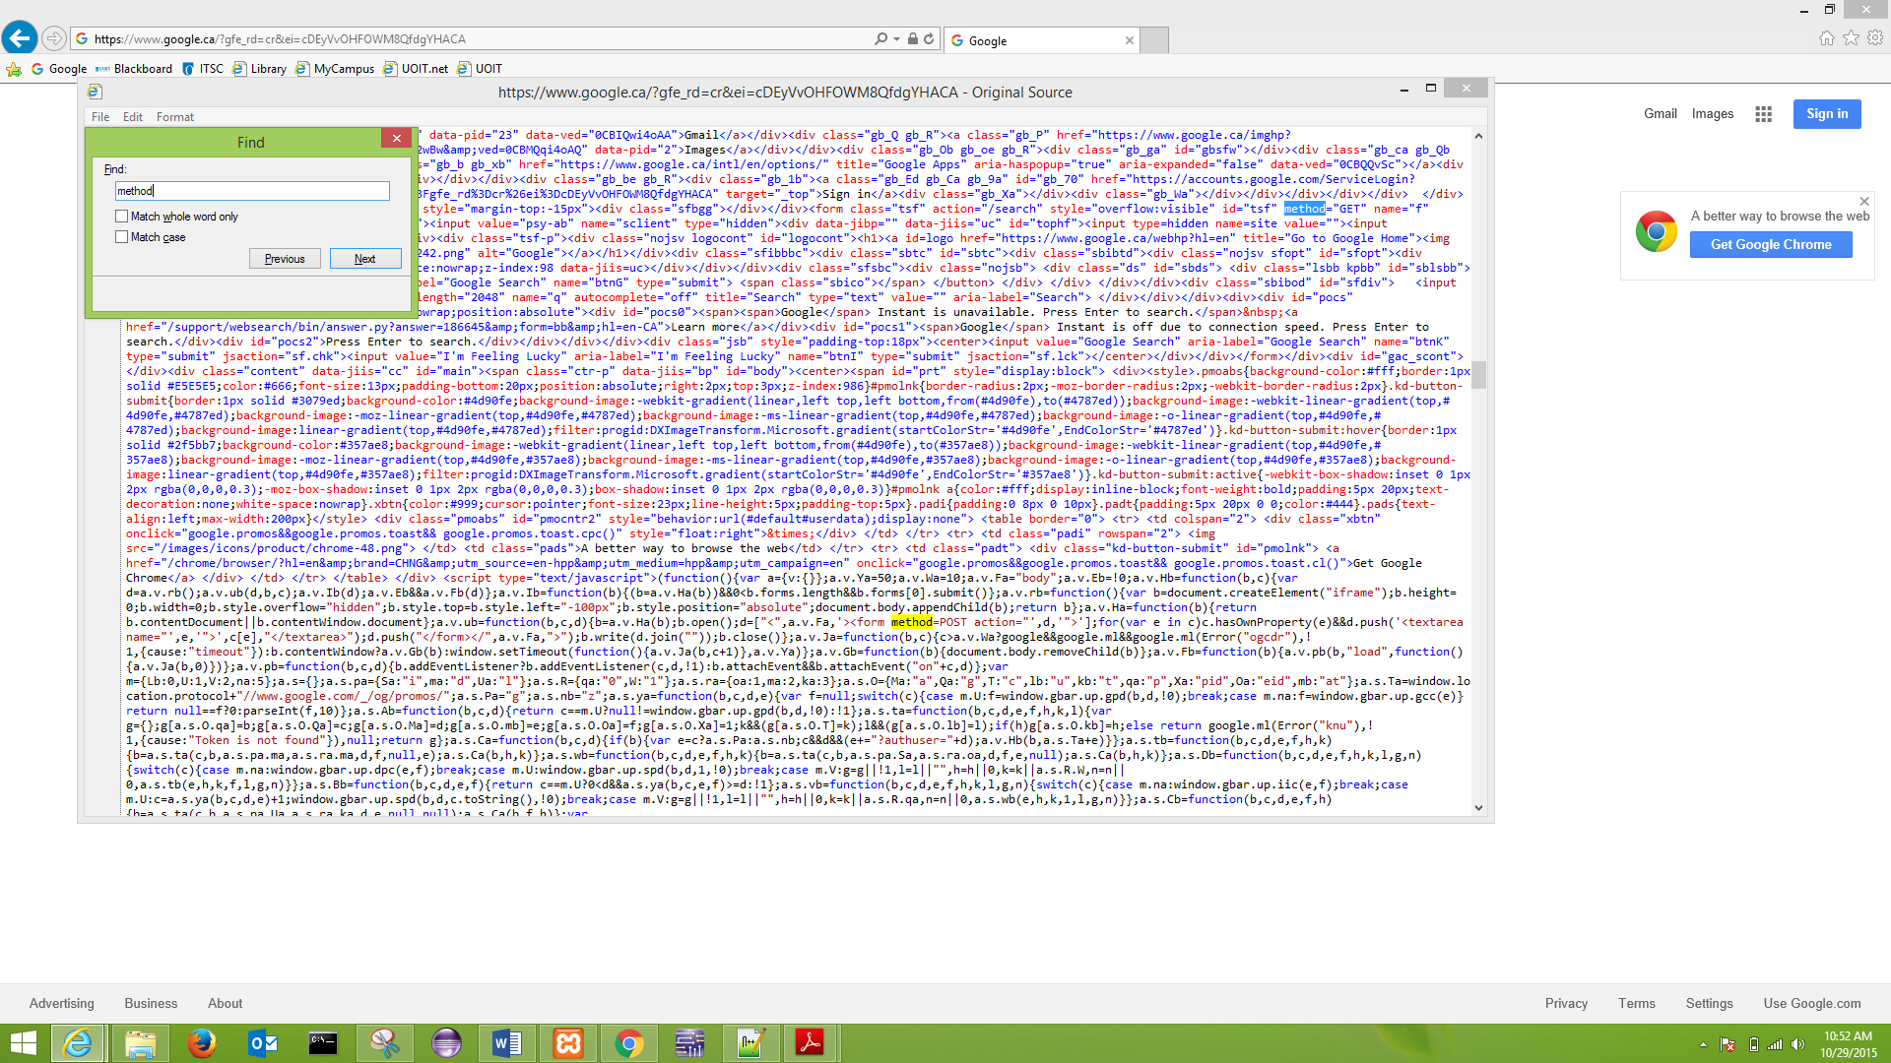 The HTTP method that Google uses in its query/search form is “GET”.
2. 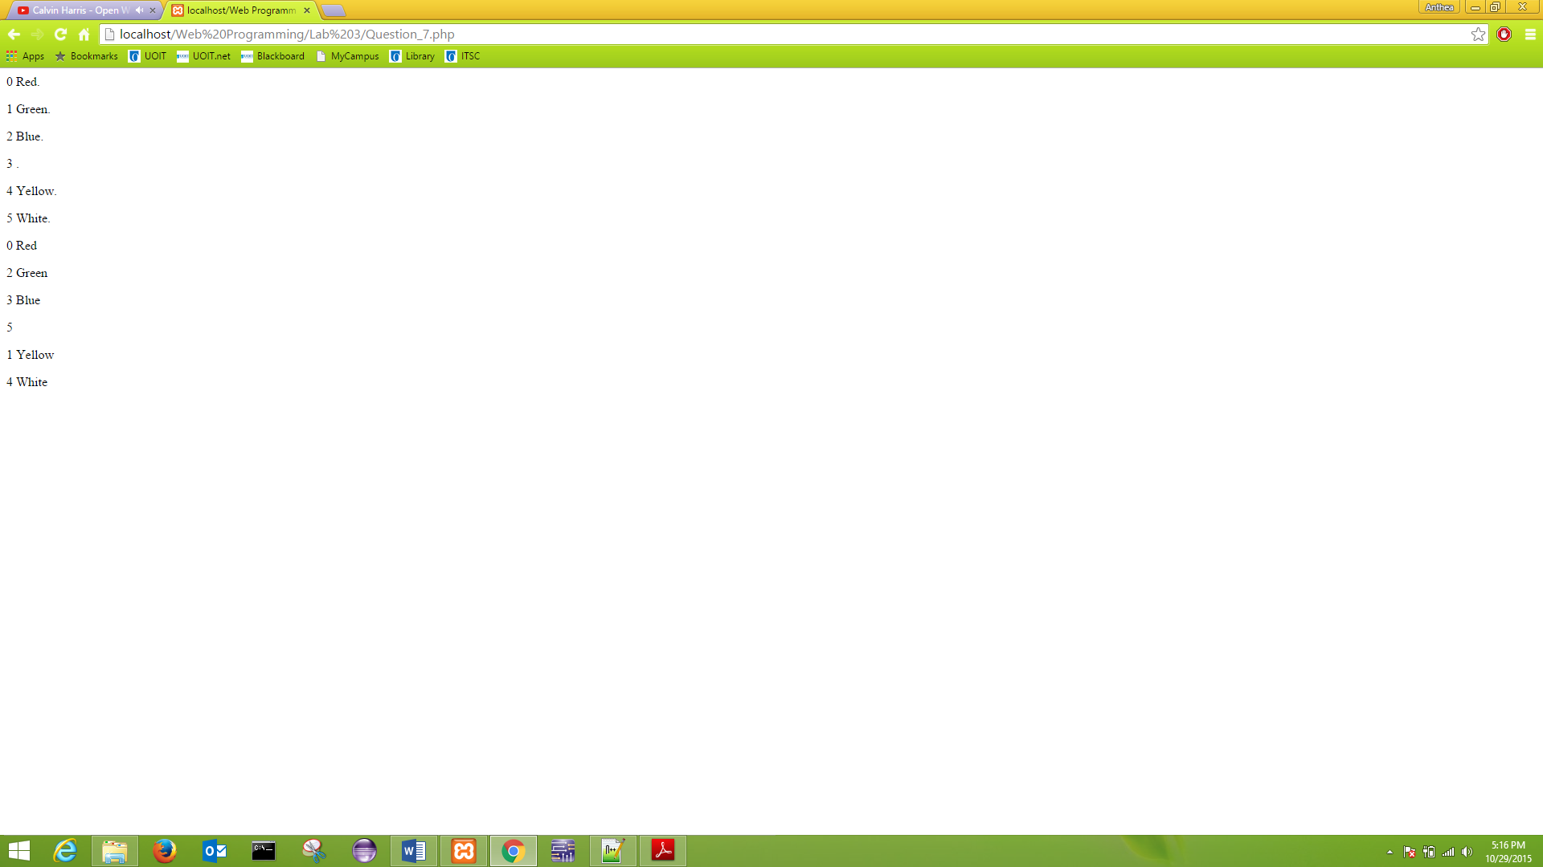This is the output for 7.1 and 7.2. (Question_7.php)
3. The output of the code for Question 8 and 8.1 (Question_8.php)



1. The output of the code. (Question_9.php)

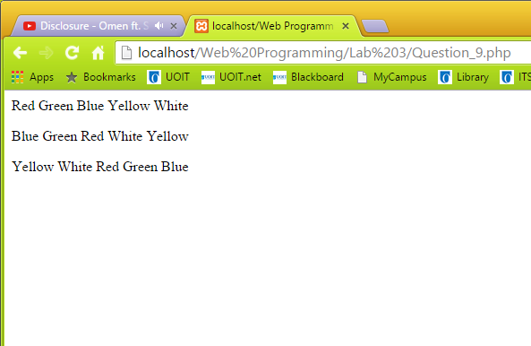

1. The output of the code. (Question_10.php)

